Laron syndrome, a rare monogenic condition
Laron syndrome (named after the medical researcher who first described it) is a very rare monogenic condition, affecting about 0.00004% of the population worldwide. People with Laron syndrome are very short and, interestingly, have practically zero incidence of cancer and an abnormally low risk of cardiovascular disease. We know that this syndrome is caused by mutations in a particular gene.
In this worksheet you will have a chance to practice your genetic analysis skills, as well as some molecular and population genetics principles, using Laron syndrome as the phenotype of interest. If you are curious, you can find more information about it on OMIM: https://www.omim.org/entry/262500

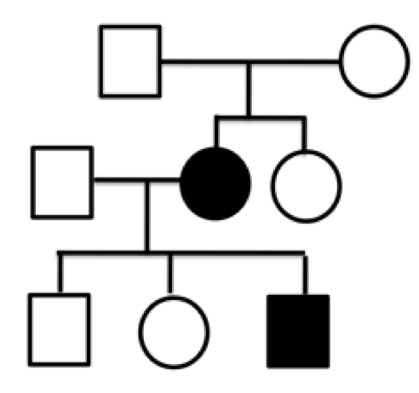
- The pedigree depicted below shows the inheritance of Laron syndrome in a small family. Using the notation “L1” to indicate the allele that is responsible for Laron syndrome, and “L2” to indicate its wild-type counterpart, assign genotypes to all the individuals in the pedigree. If multiple genotypes are possible, indicate both.

- What does it mean for a phenotype, or for an allele, to be dominant to another? (Please don’t use the word “expressed”: recall that “expressed” refers to genes and means “transcribed”).

- Based on the pedigree shown above, could the Laron syndrome phenotype be dominant to wild-type (i.e. non-Laron syndrome)? Explain your reasoning using evidence from the pedigree.

- Based on the pedigree shown above, could the Laron syndrome phenotype be recessive to wild-type (i.e. non-Laron syndrome)? Explain your reasoning using evidence from the pedigree.

- (Extra challenge) Based on the pedigree shown above, could the Laron syndrome phenotype be neither dominant, nor recessive to wild-type (i.e. non-Laron syndrome)? Explain your reasoning using evidence from the pedigree, and include a brief description of what “neither dominant nor recessive” means.

- Inspect the pedigree again. Is there any evidence that Laron syndrome may be X-linked? Explain your reasoning using evidence from the pedigree.

- Can X-linkage be ruled out using information from the pedigree? Explain your reasoning.

- Consider all the information you have up to this point. What is the most likely mode of inheritance of Laron syndrome? Explain your reasoning/defend your answer.

- In the general population Laron syndrome is extremely rare. However, there is a small village in Ecuador where it is relatively common - almost 5% of the population is affected! If the pedigree shown above was that of a family from this small village in Ecuador, instead of a family from somewhere else in the world, would your answer to Question 8 be different? Explain your reasoning.

- Assuming that the population of the small village in Ecuador is mating randomly with respect to Laron syndrome, and knowing that there is very little immigration to/emigration from the village, estimate the frequency of the “L1” allele in that population. Please include your logic, all your calculations, and any assumptions that you are making.

- Using the same assumptions as in Question 11, what proportion of the population in the small Ecuadorean village are expected to be:
  - homozygous L1/L1?
  - heterozygous (L1/L2)?
  - homozygous L2/L2?

- (Extra challenge) Keeping in mind the frequencies that you calculated in Question 11, and your answers to previous questions, what is the probability that two phenotypically wild-type people from the Ecuadorean village have a child with Laron syndrome? What about this probability in the general world population?

- Do you think that Laron syndrome is subject to selection? Defend your answer using the data provided, logic, and your knowledge of genetic principles. Please also include whether the selection in question (if applicable) would be positive or negative.

- Use the data provided, logic, and your knowledge of the principles of genetics and evolution, to propose a hypothesis that would explain how Laron syndrome came to be so much more frequent in the small village in Ecuador compared to the rest of the world.

- Laron syndrome results from mutant alleles of the gene encoding the human Growth Hormone Receptor (GHR). The GHR protein is necessary to produce a growth factor, which in turn plays a crucial role in the growth of the organism. Describe three different types of gene mutations that would result in no production of functional GHR protein, and explain how each of the three mutations has this result.

- (Extra challenge) Consider each of the three GHR mutant alleles that you described in Question 15. If we were interested in the phenotype “transcription of the GHR gene”, instead of being interested in the Laron syndrome phenotype (short stature, etc.), would each of your three mutant alleles be dominant, recessive, or neither dominant nor recessive to the wild-type GHR allele?

